UNIT 4: ANTIDERIVATIVES AND INTEGRATION

3.9: Antiderivatives

 -----------differentiate----------🡪 ________________________

<---------- ------------

_____________ ----------------------------------------🡪 

<---------------------------------------

 is called an __________________________________ of 

Notation: Generally asked in this way: Given that , find *an* antiderivative. That is, find  such that . Using this notation,

 is called *an* antiderivative of .

So  is *an* antiderivative of . Are there others?

From theorems I asked you to read in section 3.2, which are proved via MVT:

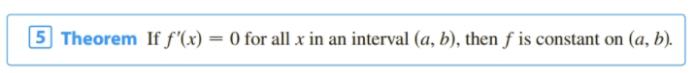

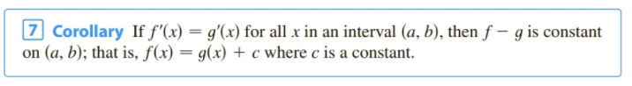

So  is *an* antiderivative of ,  is *the most general* antiderivative of  (family of curves)

Exampe: Find the general antiderivative for each of the following:

 __________________________________

 __________________________________

 __________________________________

 __________________________________

 __________________________________

 __________________________________

 __________________________________

 __________________________________

 __________________________________ (Properties)

 __________________________________

 __________________________________

Example: Finding a specific antiderivative: Find  given that  and 

Application of Antiderivatives: Rectilinear Motion

In Chapter 2 we learned that if an object is moving in a straight line having position given by :







Chapter 4 : Integrals

4.1. Motivation for Integration – Two Classic Problems

1)_________________________________ 2)_________________________

The Area Problem: Given f(x) $≥$ 0, continuous on I=[a, b]. Find the area below f(x) and above the x axis, over I.

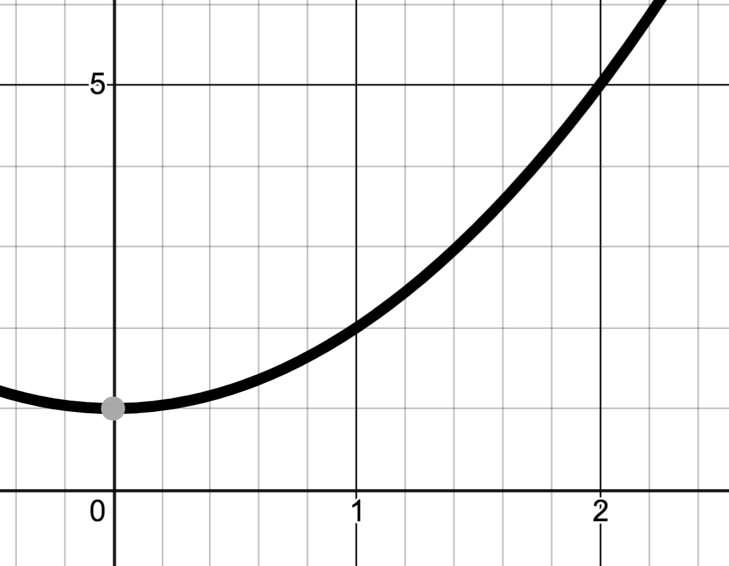

Example: Find the area below , over [0, 2]

Suppose we cut the region into 4 vertical strips of equal width. What would the width be? ______________________ How do we find the x value for the location of each of these strips? These strips could be approximated by rectangles. How do we decide where to draw the tops of the approximating rectangle?

Left Right

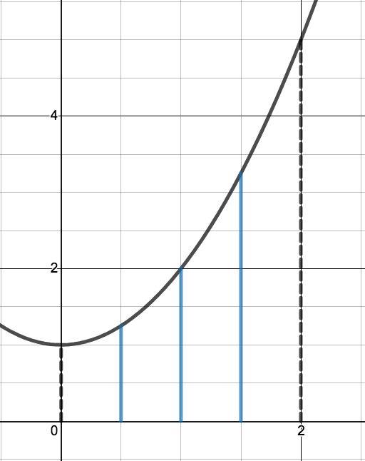 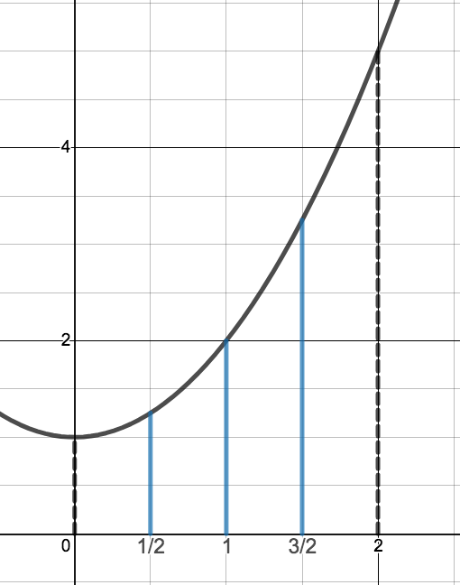

How could we get a better approximation?

Consider 8 vertical strips of equal width. What is the width? X values?

Left Right

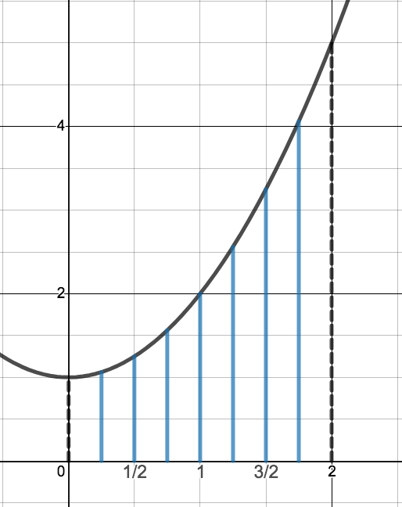 

 

<https://www.desmos.com/calculator/yfs11mco2v>

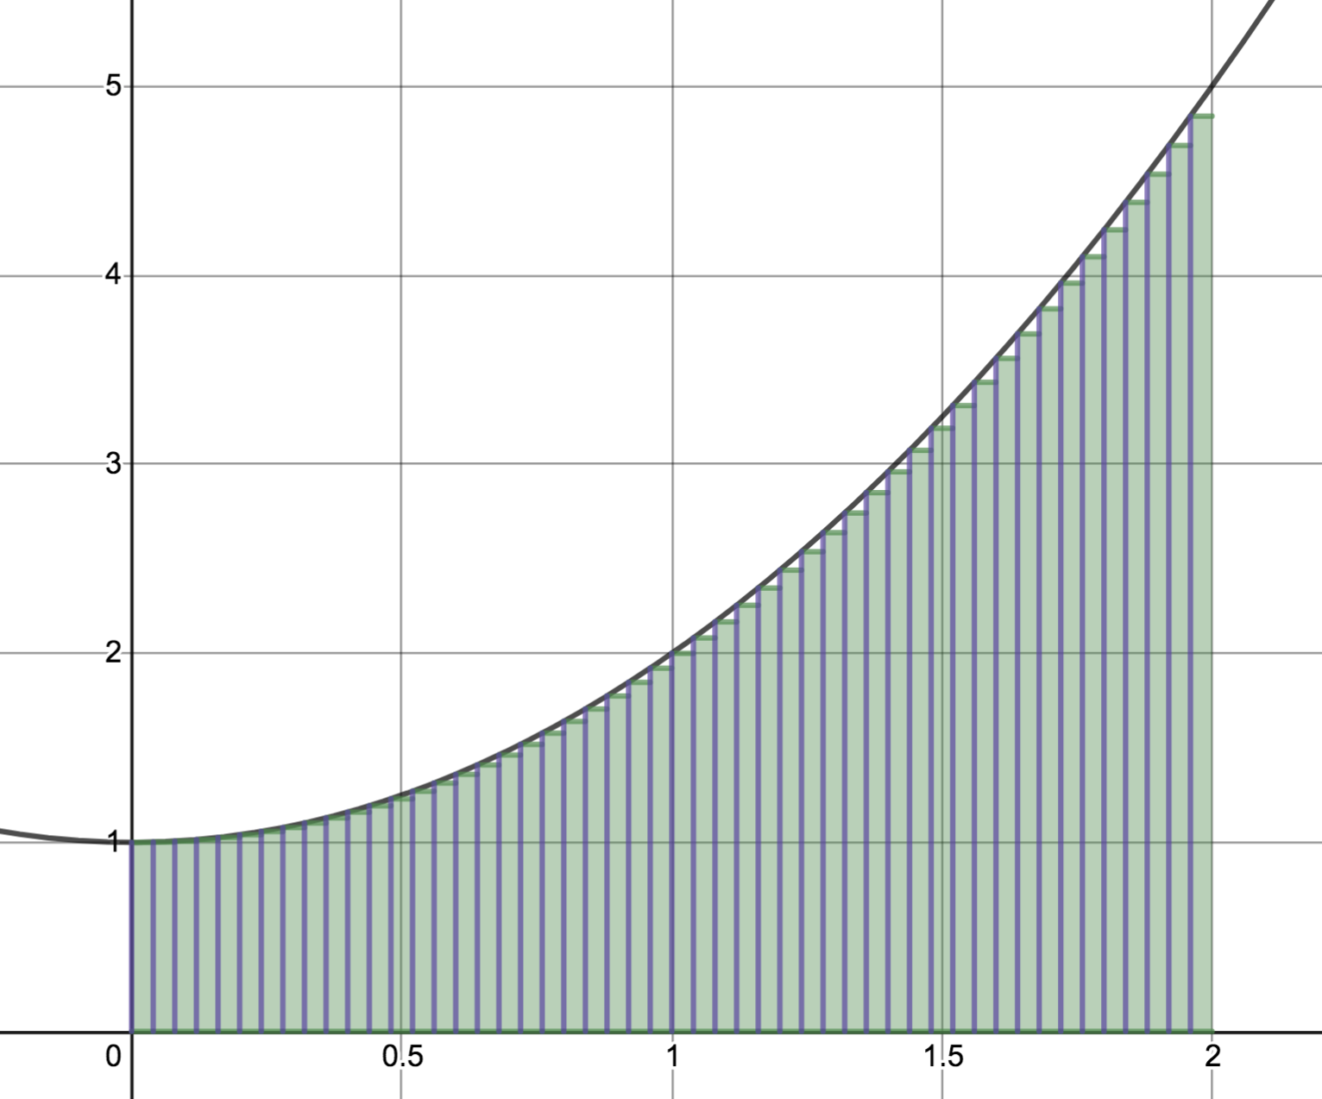 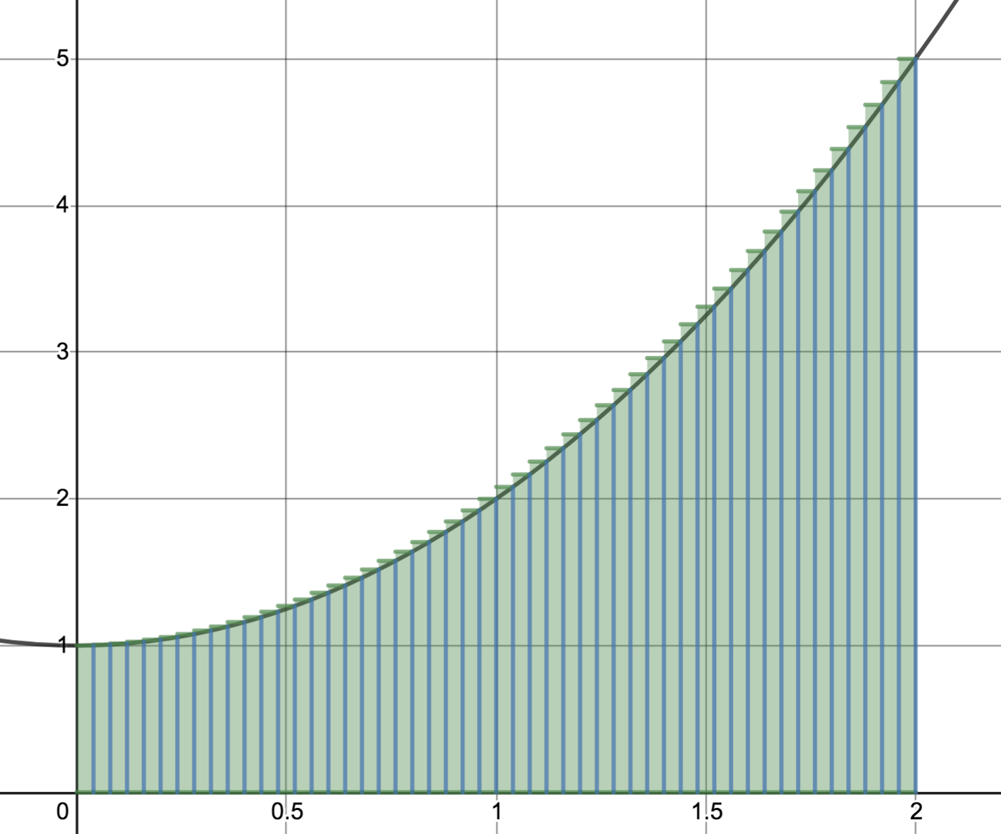

 

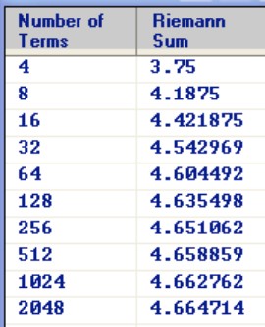 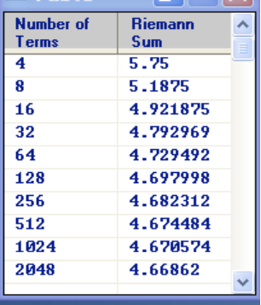

Another approach: Use the midpoint as sample point to determine the height of the rectangle.

 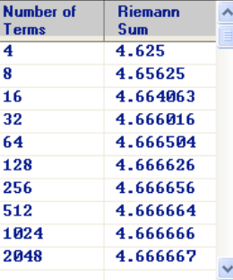

What if the sample point is randomly chosen?

 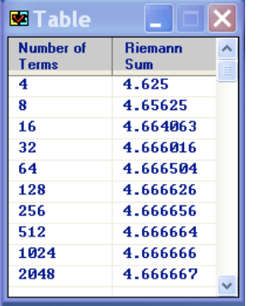

In the next section, we will revisit this problem and use limits to find the area exactly.

The Distance Problem

How can be find the distance traveled by an object if we know its velocity?

But what if the velocity is not constant?

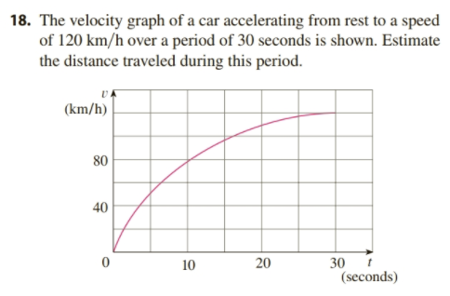

4.2 The Definite Integral

Returning to the example from the last section: Find the area below , over [0, 2].

We will use Calculus and Limits to find the area exactly..

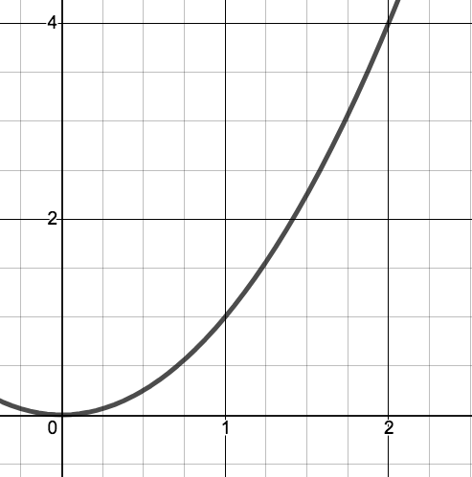Partition the interval [0, 2] into _____________ subintervals of equal width________________.

Which divides [0,2] into



where



Then Rn= (could have used Ln, Mn, random)

So AREA = 

How can we write this more compactly? How can we compute it? (See next page)

Summation (Sigma) Notation – Appendix E

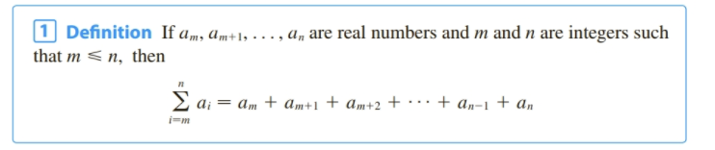

Sigma notation provides a way to express a long sum.

Example:   

So we can write 

Here are some properties that help us manipulate sums written in sigma notation.

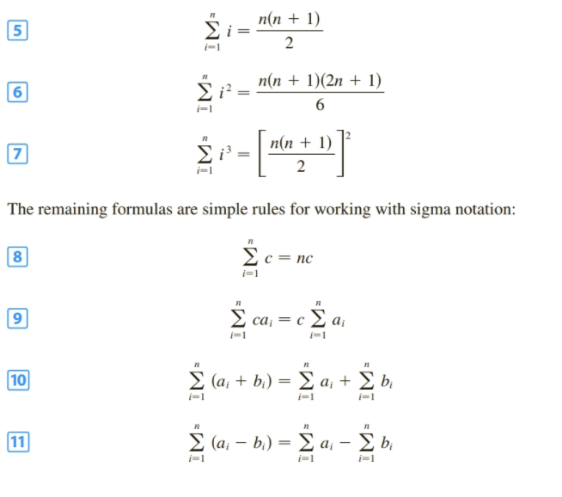

So returning to previous problem…..(see previous page)

Generalizing this process to find the area under any f(x) $≥$ 0, continuous on I=[a, b].

Partition [a,b] into n subintervals of equal width ________________________, which partitions the interval as follows:



Where ______________________________________________

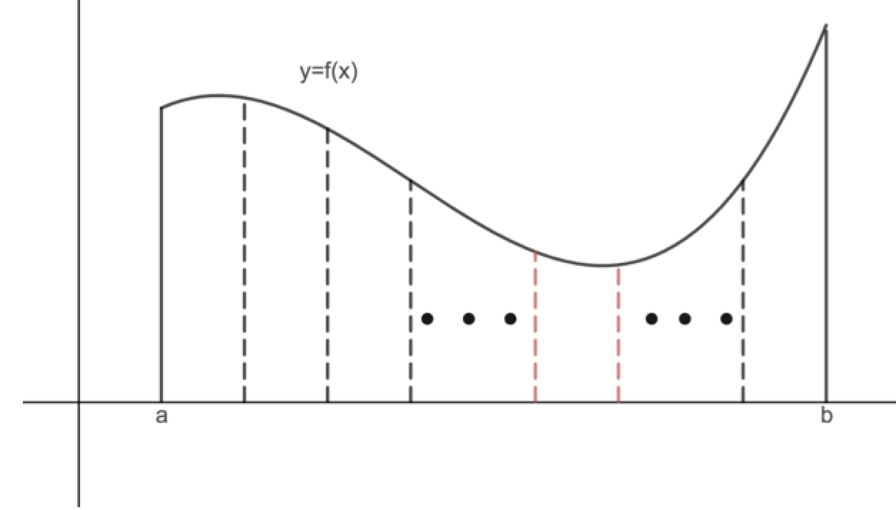

We form n rectangles, by taking an arbitrary sample point in each subinterval,  and using the functional value at that

sample point as the _________________________________ of the rectangle. The area of the ith rectangle, then, is  _________________

The area enclosed in the n rectangles is given by: ____________________________________________

The above sum is called a Riemann Sum. If we take the limit as the number of subintervals goes to infinity for this Riemann Sum, we get the (exact) area.

AREA =

It turns out, this process useful in *many* applications unrelated to area or distance, so we define the process and notation.

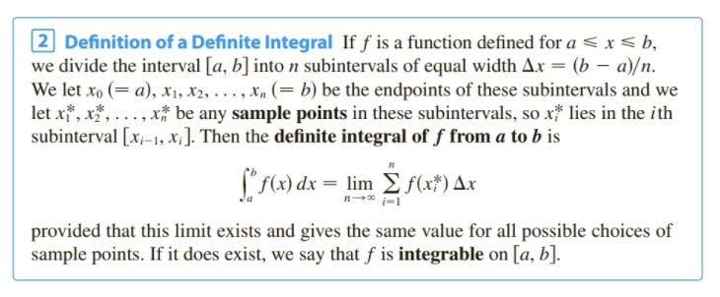

Note, if  and continuous, this is the same as the definition of area, but this definition does not make those requirements.

What would this process yield if  on [a,b]?

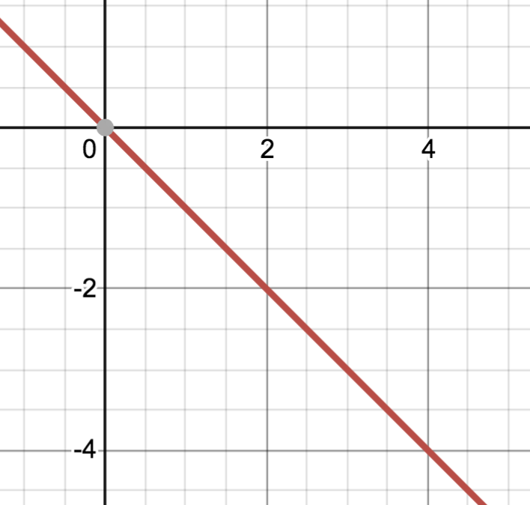Consider applying the process to the function  on [1,5]

Approximate  using L4

So  is not area. It is RELATED to area. In this case, it is the ___________________________ of area.

Important:  ONLY represents ___________________________if _____________________

Area is never _________________________, Integrals ARE sometimes ____________________

 can be thought of being RELATED to area _______________________________________

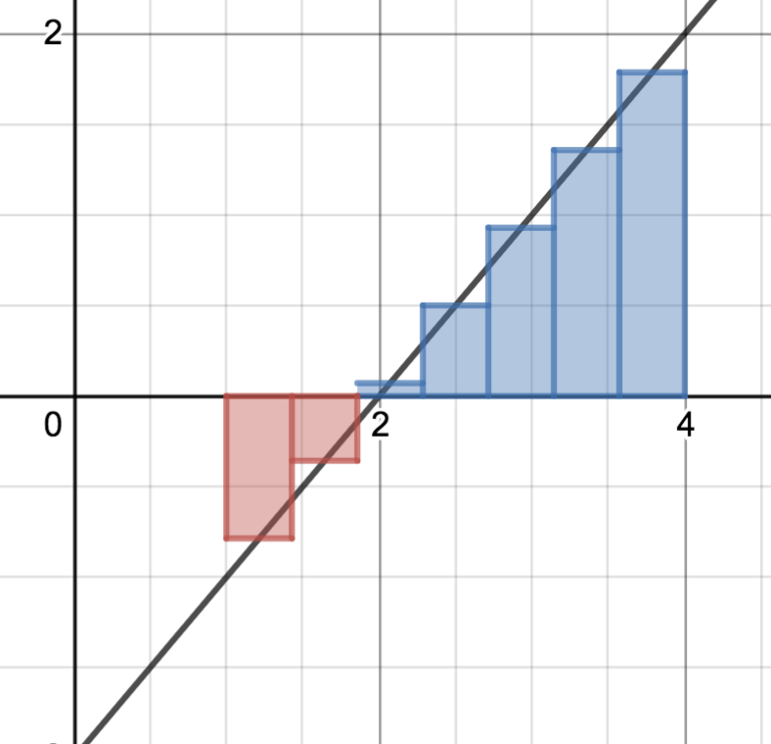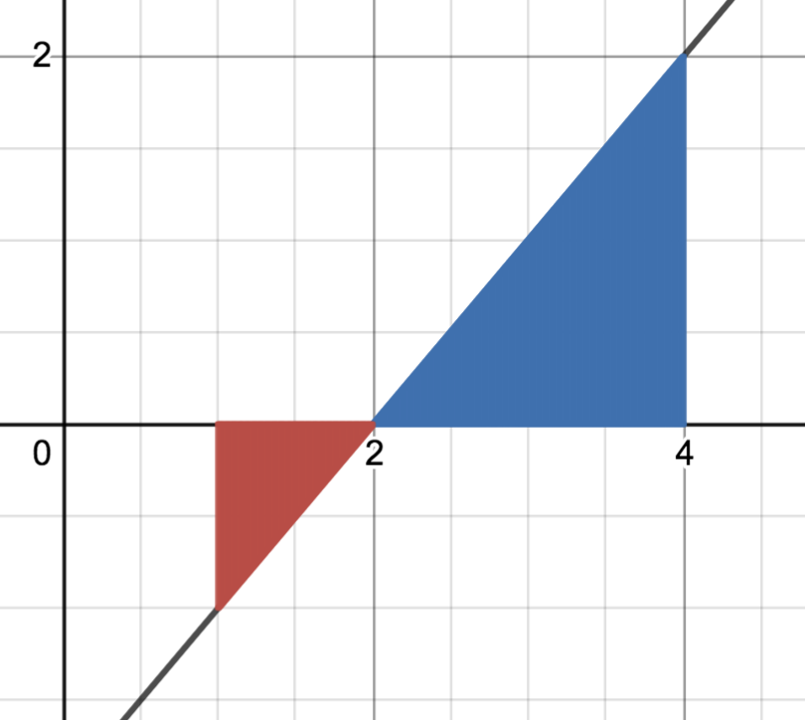Example Compute using the Riemann sum definition

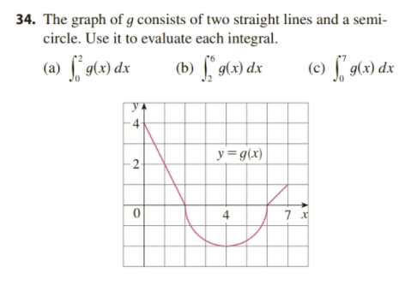

Suppose you wanted to find the total AREA enclosed between the curve and the x axis in the above problem. What integral expression would give that value?

Methods of Computing an Integral thus far;

1) Approximate using a Riemann Sum

2) Find exactly by finding the limit of a Riemann Sum

3) Use an Area (or “net signed area”) interpretation.

  

Properties of Integrals:

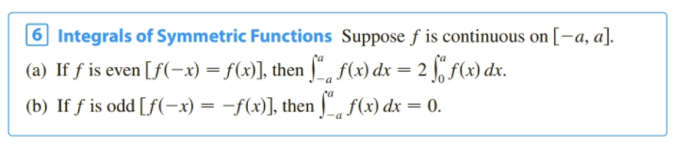

 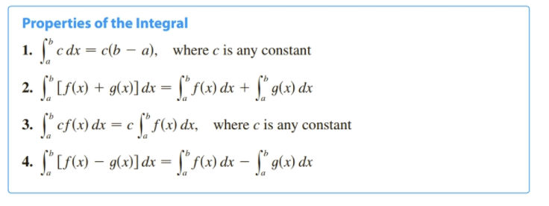

Example: 



4.3 The Fundament Theorem of Calculus

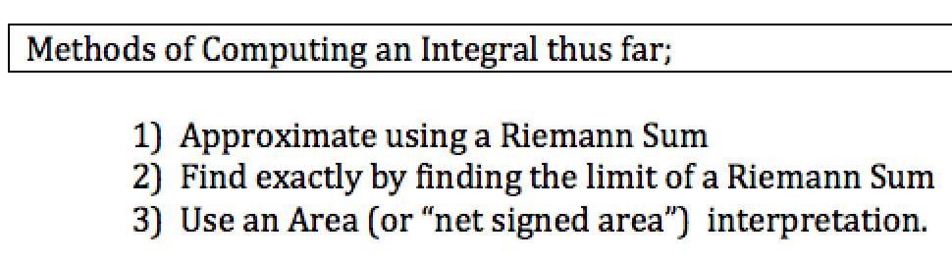

In this section we seek a better technique.

In 4.2 problem #27 we prove that 

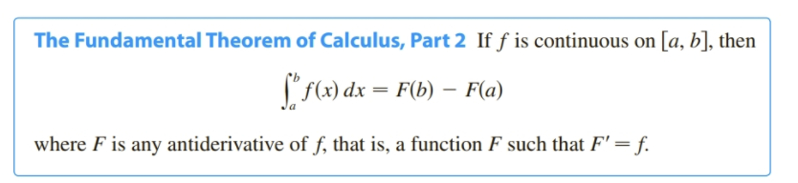

Proof:  where . Consider the interval . Applying the MVT to F(x) on ,

This theorem tells us two important things:

Examples:













Abstract example, motivating the first part of the FTC.

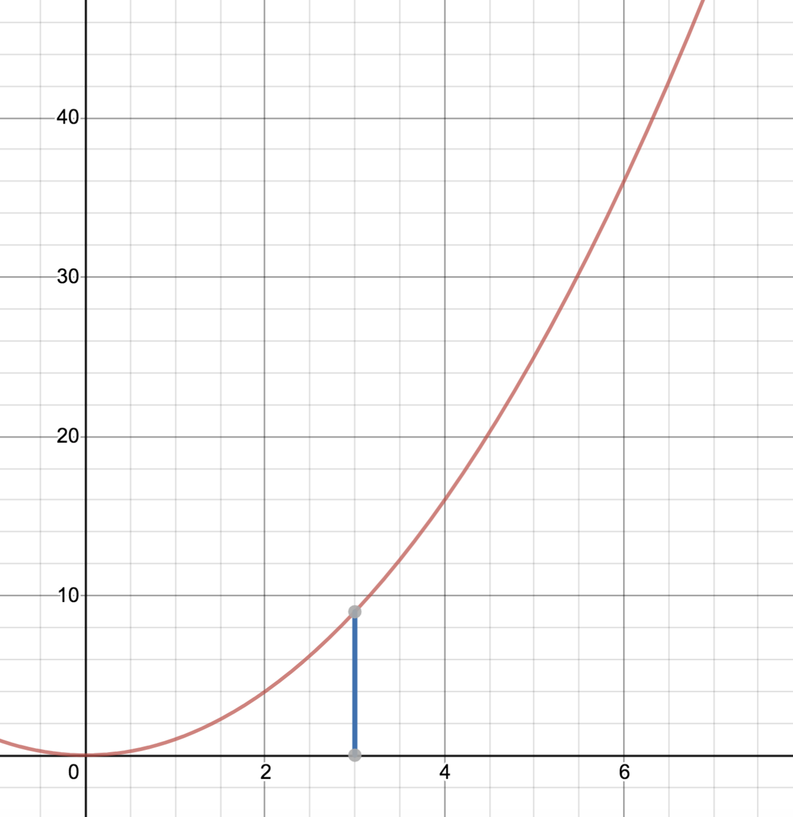



What does it mean?

How would we compute it?

What would we get if we differentiated now?

So we found that 

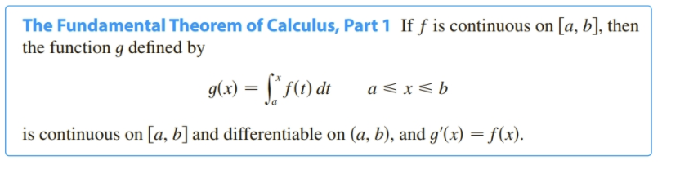

That is, 

Why is this important?

1) ______________________________________________________________________________________

2)______________________________________________________________________________________

Example. Find  

Example: 

Example involving the Chain Rule.

Back to earlier example



Before we learned FTC part 1, we computed it “the long way” by actually integrating and then differentiating.

What if we were asked:



In general  will result in a function of u so to differentiate it we will need ___________________________________



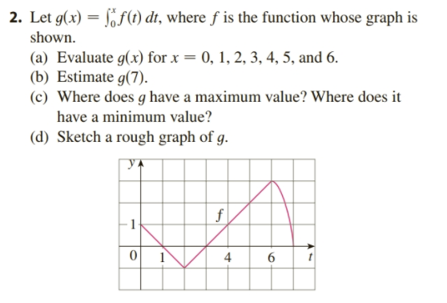 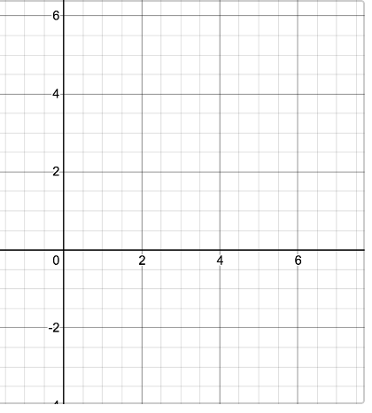

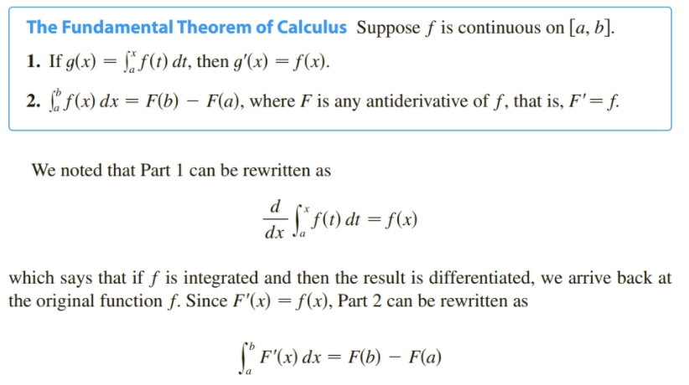

4.4 Integrating with Absolute Values – Indefinite Integrals – Net Change Theorem

Lead in example: Find the area enclosed between  and the x axis on [0, 3]

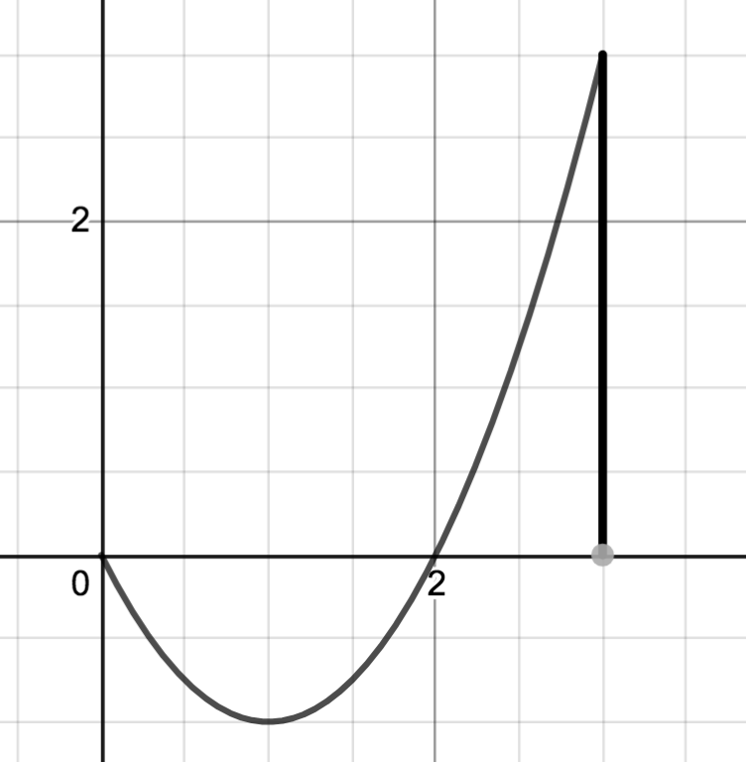

The total area enclosed between f(x) and the x axis over [a, b]: A= 

So for the previous example, . But how would we compute that?

Recall:  Compute: 

Similarly:  so 

Net Change

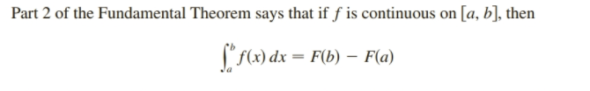

where F’(x) is any antiderivative of f, thus F’(x)=f(x). This leads to:

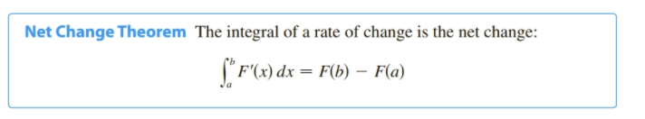

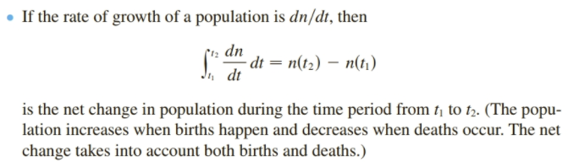Examples:

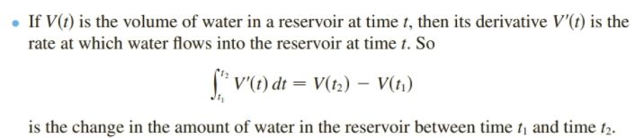

Displacement vs Distance traveled.

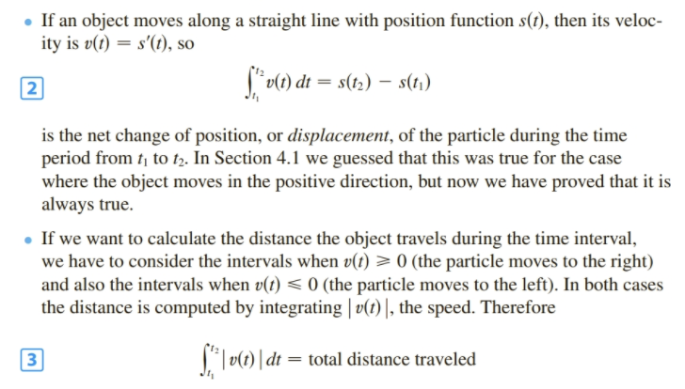

Example:

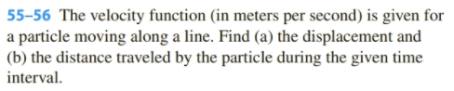



Displacement: 

Distance: 

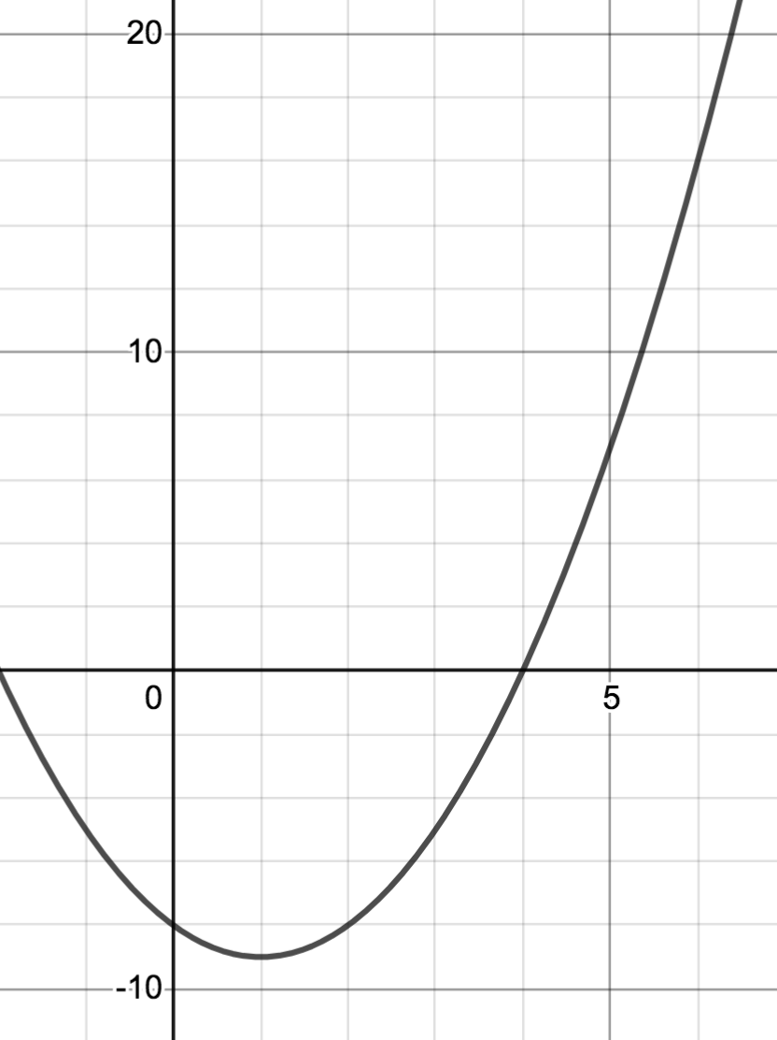

Evaluate movememt:

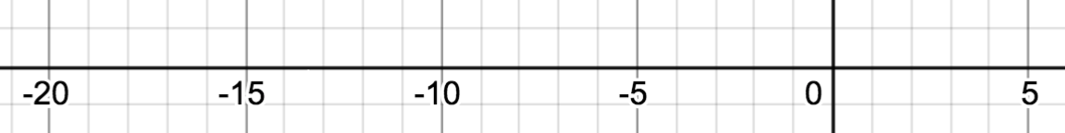

Previously, we considered  Note: The result is a _____________________________

We now introduce a new notation:

Indefinite Integrals

 where F(x) is the general antiderivative, so will include a +C

Note: The result is a______________________________________

Example:





 Book Notation: 



4.5 Integration by Substitution

So far, the only antiderivatives we can find are:

Today we will learn a new method for helping us find more antiderivatives.

Recall from section 3.9:  -----------differentiate----------🡪 ________________________

<----------antidifferentiate -----

or using derivative and integral notation:  ____________________________

________________

Suppose f is a composite function  ____________________________

___________________ 

 ____________________________

___________________ 

In general, the chain rule tells us  ____________________________

S0

___________________ 

Examples: Choosing u well takes practice. You will begin to “see” two steps ahead whether your choice of u might work.













Definite integrals with u-substitution:



Changing to U’s limits Keeping x’s limits: Watch noation!





5.1 Area Between Curves (development in book differs)

Finding vertical distance: Finding Horizontal distance:

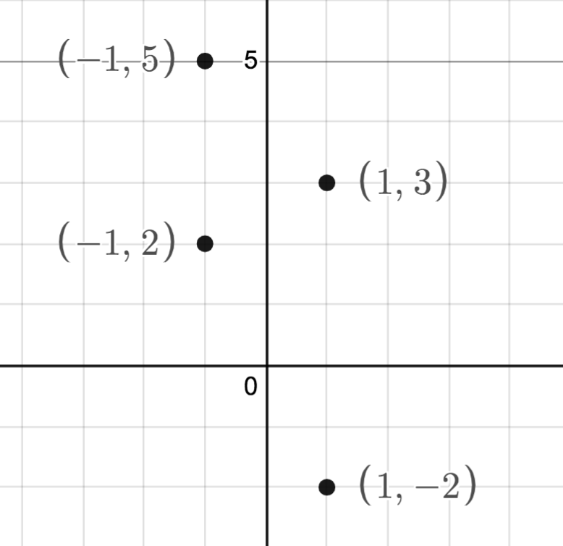

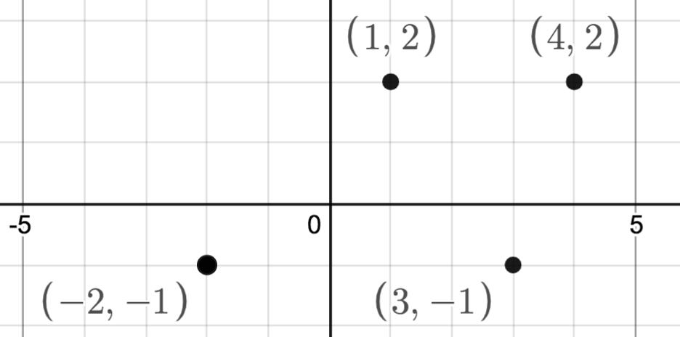

Suppose and  are continuous on [a, b] with  for all x in [a, b]. Find the area enclosed between  and  over [a, b].

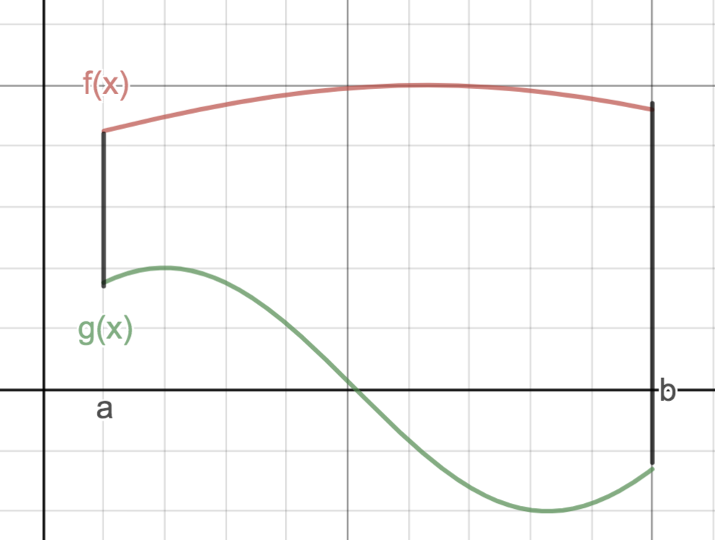

Example: Find the area of the region bounded by y=x+6 and y=x2 over [0,2] (Ans 34/3)

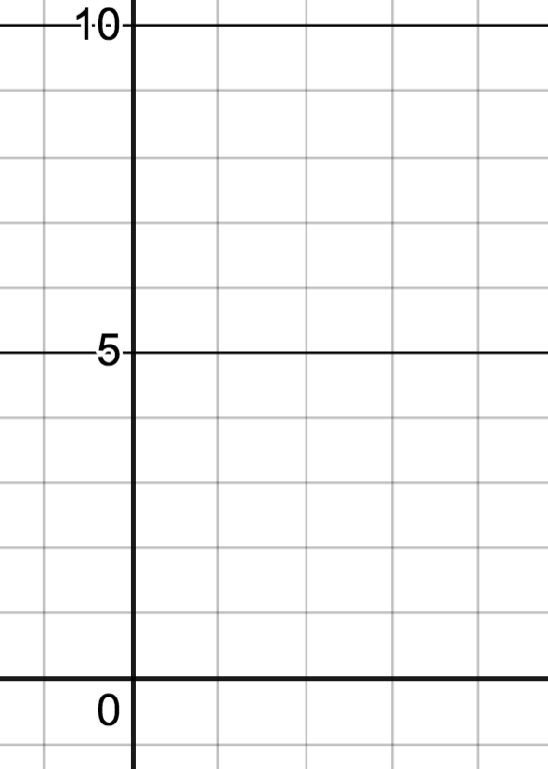

Example: Find the area of the region bounded by y=x and y=x2 . (Ans 1/6)

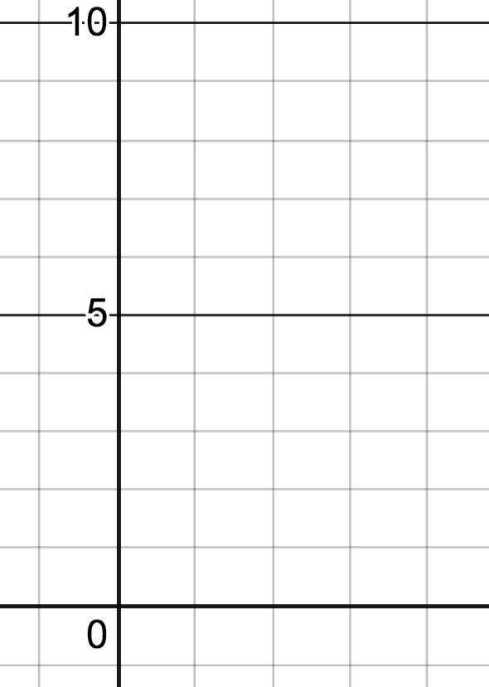

Example: Find the area of the region bounded by x+y=4, y=2 and y=x2 +2 (Ans 5/6)

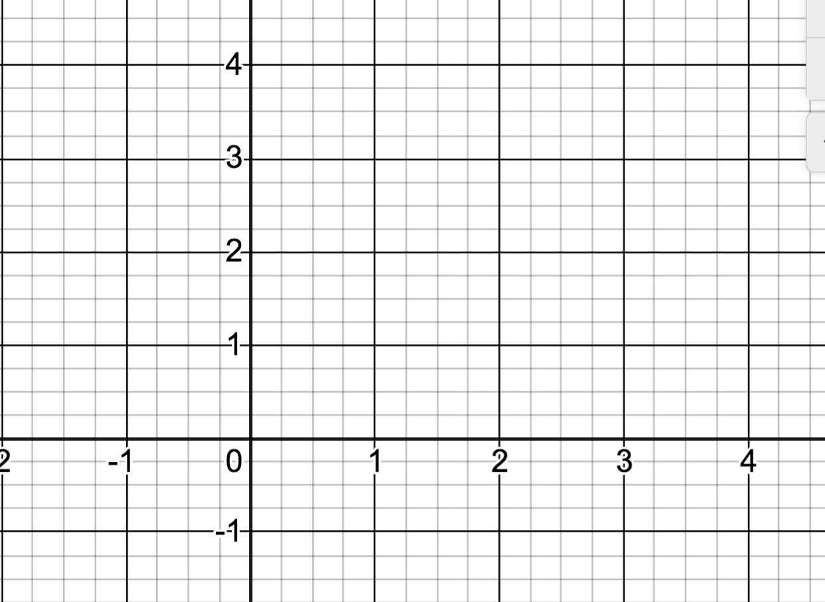

Consider looking at functions from a different point of view:

  

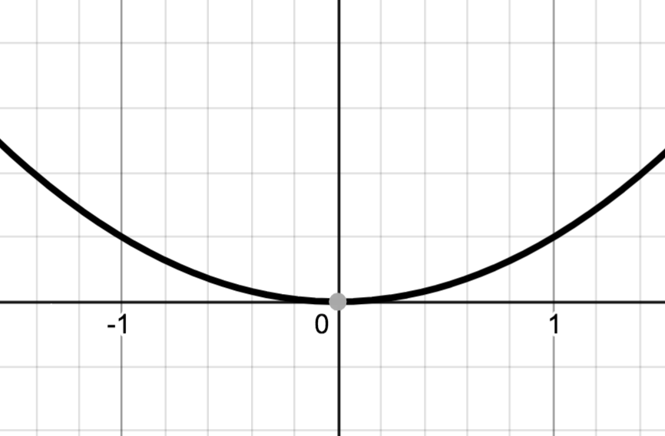 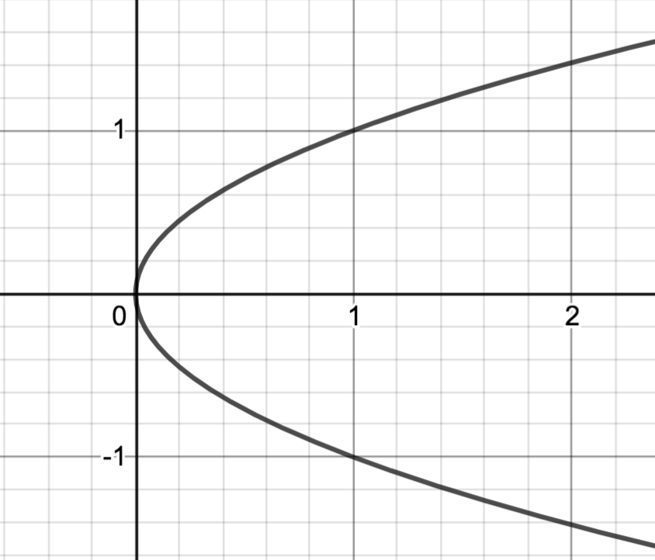 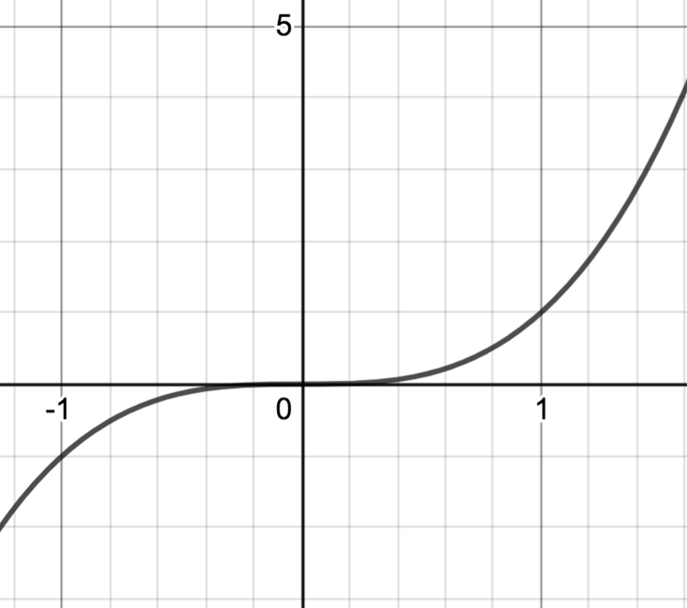

Some curves make more sense to view with y being the independent variable and x being a function of y.



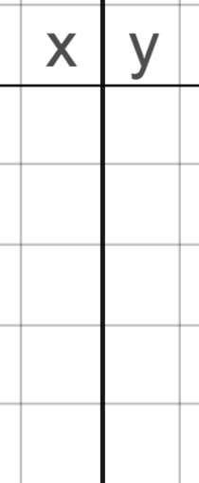

Example: Find the area of the region bounded by  and the y axis for  (Ans 2/3)



In general suppose and  are continuous on  with  for all y in [c, d]. Find the area enclosed between  and  over [c, d].

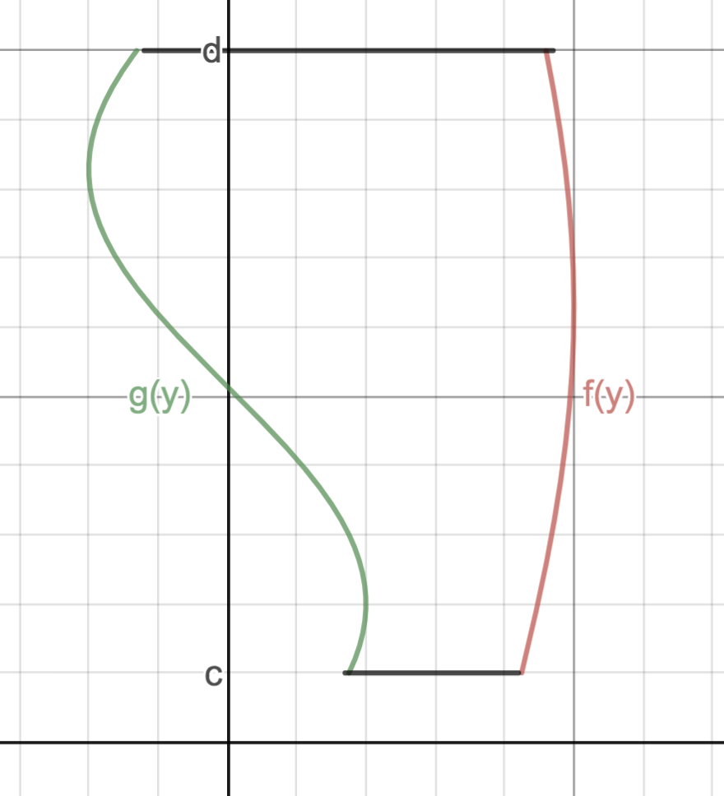

Redo example, this time with respect to y: Find the area of the region bounded by x+y=4, y=2 and y=x2 +2

